

Lab # 4

Web Engineering
Fall 2020



Instructor | Mr. Safdar Ali
Student Name | Muhammad Taha
CMSID | 518133
Department | Computer Science
Semester | 05

Lesson Set Introduction to _{Media Query}Box Model and 4

Purpose | 1. | To get a basic awareness of VS Code
 | 2. | To understand HTML and why we are using it.
 | 3. | To learn the basics of an editor and create simple pages.
 | 4. | File Handling
Procedure | 1. | Students should read the Pre-lab Reading assignment before coming to the lab.
 | 2. | Students should complete the Pre-lab Writing assignment before coming to the lab.
 | 3. | In the lab, students should complete Labs 4.1 through 4.4 in sequence. Your instructor will give further instructions as to grading and completion of the lab.
 | 4. | Students should complete the set of lab tasks before the next lab and get them checked by their lab instructor.
 | Contents |  | Pre-requisites | Completion Time | Page Number
 | Pre-lab Reading Assignment |  | - | 20 min | 3
 | Pre-lab Writing Assignment |  | Pre-lab Reading | 10 min | 4
 | Lab 4
 | Lab 4.1  Installing VS Code |  | Pre-lab reading | 30 min | 5
 | Lab 4.2 Lab Tasks |  | Awareness with VS code | - | 9

PRE-LAB READING ASSIGNMENT

What Is Box Model In CSS and HTML, the Box Model refers to the concept of a rectangular box that wraps around every HTML element on a web page, such as text, images, and other elements. The box is made up of four parts: content, padding, border, and margin.
Content: It is the area inside the box that contains the actual content, such as text, images, or videos.
- Padding: It is the space between the content and the border. It can be used to add extra space between the content and the border.
- Border: It is a line that surrounds the padding and content of the box. It can be styled in various ways, such as color, width, and style.
- Margin: It is the space outside the border. It can be used to create space between the box and other elements on the web page.
Together, these four parts of the box model determine the total size and shape of an HTML element on a web page. Understanding the box model is important for properly positioning and styling elements on a web page using CSS.

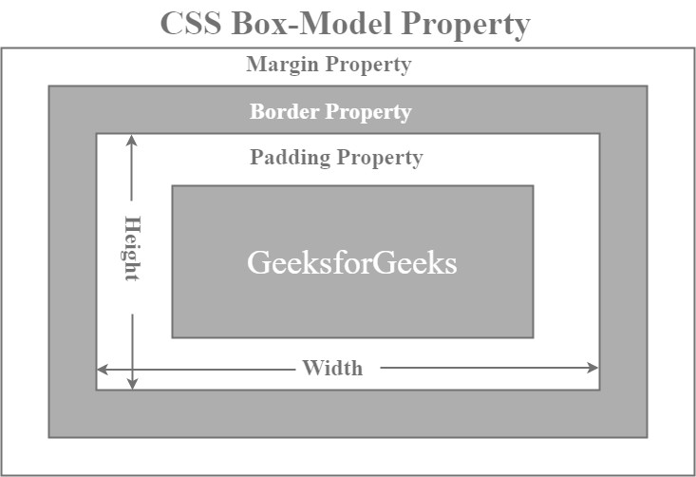

Media Query Media queries in CSS allow you to apply specific styles to a web page based on certain conditions, such as the screen size of the device being used to view the page. Media queries are commonly used in responsive web design to create a layout that can adapt to different screen sizes and devices.
The basic syntax for a media query is as follows:

@media screen and (max-width: 768px) {
/* CSS styles go here */
}

In this example, the media query applies styles only when the screen width is 768 pixels or less. You can also use min-width to apply styles only when the screen width is greater than a certain value. Media queries can also be used for other conditions, such as device orientation, screen resolution, and more. For example:

@media (orientation: landscape) {
/* CSS styles for landscape orientation */
}

@media (resolution: 300dpi) {
/* CSS styles for high-resolution screens */
}

Media queries can be very powerful tools in creating flexible, responsive web designs that can adapt to a wide range of devices and screen sizes.

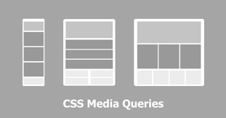

PRELAB WRITING ASSIGNMENT

Fill in the blanks | - Media queries allow developers to apply styles based on the device or screen properties.  - The CSS Box Model in CSS defines the properties of an HTML element's content, padding, border, and margin.  - The child (>) CSS selector is used to target only the immediate child element of a parent element.  - The :nth-child() CSS selector is used to select HTML elements based on their index number in relation to their siblings.  - Using media queries, it is possible to apply different styles to the same HTML element based on the size of the device screen.

Lab 4.2 Lab Tasks

- What is 12 Column Grid explain with example.
A 12-column grid is a layout system used in web design to divide a webpage into 12 equal columns. It makes it easier to create responsive and organized layouts.
For example, a webpage can be divided like this:
Column 1 | Column 2 | Column 3 | Column 4 | Column 5 | Column 6 | Column 7 | Column 8 | Column 9 | Column 10 | Column 11 | Column 12
A section can use different numbers of columns. For example:
- 6 columns → half of the page
- 4 columns → one-third of the page
- 3 columns → one-quarter of the page
- 12 columns → full width
Example: A webpage can have a 4-column sidebar and an 8-column main content area:
[ Sidebar: 4 columns ][ Main Content: 8 columns ]
This system is commonly used with CSS Grid to create responsive web layouts.

- Make a responsive resume web page with HTML and CSS only and upload on GitHub Pages

